HOMEWORK No 3

Example Model:

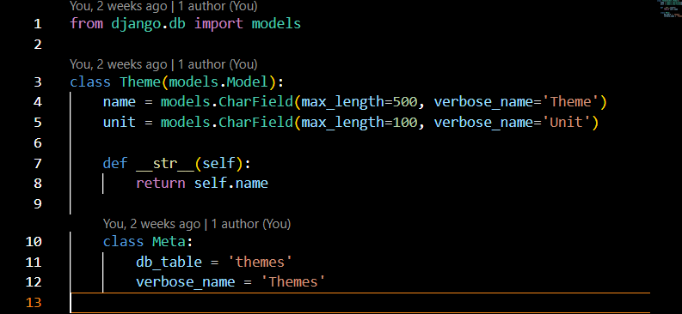

Django shell:

1. python manage.py shell

2. from theme.models import Theme



3. themes = Theme.objects.all()

themes

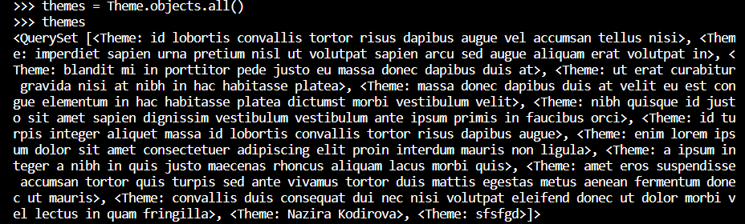

Filter:

Mavzuning ***name = “****Nazira”* bo’lgan Mavzular ro’yxatini ko’rish:

4. themes = Theme.objects.filter(name="Nazira")

themes

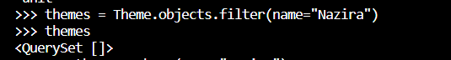

Yangi mavzu qo`shish va save qilish:

5. new_theme = Theme(name="Nazira")

new_theme.save()



Mavzu ro`yhatini qaydan tekshirib ko`ramiz va 👇natija:

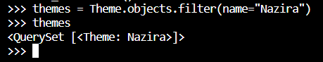

Create Model:

Metod (1):

6. theme = Theme(name="Create Models", unit=2)

themes

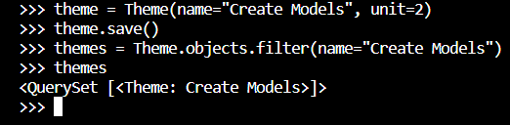

Metod(2):

7. Theme.objects.create(name="Grokking Algorithms", unit=5)



Update Model:

Metod(1):

8. themes = Theme.objects.all()

theme = themes[0]

theme.unit = 21

theme.save()

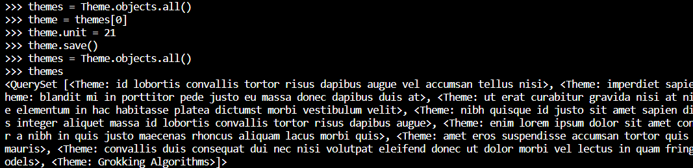

Metod(2):

9. Theme.objects.update(name="new data")

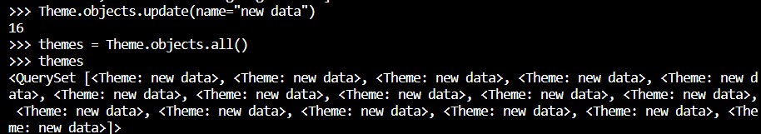

Metod(3):

10.Theme.objects.filter(name="new data").update(name="Grokking Algoritms")

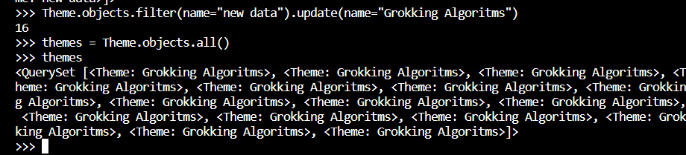

Django Extensions:

11. pip install django-extensions

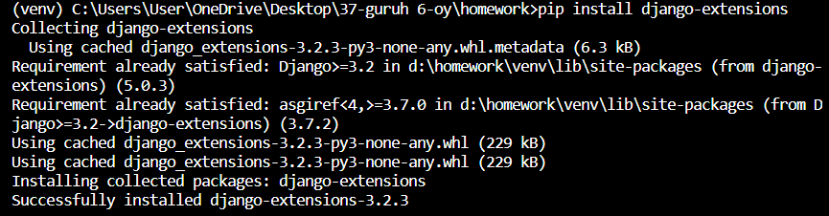

12. settings.py

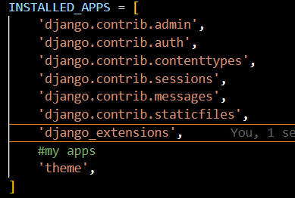

13. python manage.py shell_plus

